Edinburgh University Press Corporate/Books Site

Accessibility Evaluation

Anna Glazier, Kirsten Knight & Keara Mickelson

Marketing Department, Website Team

November 2025

To request this document in an alternative format e.g. large print, Braille et. Cetera please contact Kirsten Knight on +44 (0)131 650 4218 or email accessibility@eup.ed.ac.uk.

Introduction

The following is a summary of accessibility testing for the Edinburgh University Press Books/Corporate website https://edinburghuniversitypress.com/.

The Edinburgh University Press Books/Corporate website is the central source of information about EUP’s publishing output and mission and it is also a direct-to-consumer ecommerce platform for our print books and digital products. The site is publicly available and allows users to browse our entire catalogue of books, series and authors as well as a range of informational pages about the areas of research we publish in, the publishing process, Open Access publishing, customer service and information about where libraries and bookshops can purchase our books. Users may also create an account where they can access purchased books. The website also links out to other EUP platforms (the EUP journal content platform and the EUP blog) and hosts embedded forms for sign-ups to newsletters. Purchased eBooks can also be accessed in the Glassboxx app. For more information about the Glassboxx app’s accessibility, visit Glassboxx accessibility information.

The site was tested on a PC, primarily using the browsers Microsoft Edge (114.0.1823.67), Firefox (102.13.oesr) and Google Chrome (141.0.7390.108) for comparative purposes. We test on Firefox, Chrome and Edge to ensure breadth and variety.

A recent world-wide usage levels survey for different screen readers and browsers (WebM: Screen Reader User SurveyAI) shows that Chrome is increasing in popularity and is now the favoured browser for seen readers.

We initially tested the site through automated testing software WAVE WebAIM. It is important to recognise the limitations of solely using either method, manual testing does provide a more comprehensive overview of accessibility in comparison to automated variants.

The automated WAVE Evaluation Tool picked up:
- Elements in footer do not meet minimum colour contrast ratio thresholds (1.4.3 Contrast (Minimum) (Level AA))
- Elements have structural errors in the form of skipped headings (1.3.1 Info and Relationships (Level A), 2.4.1 Bypass Blocks (Level A), 2.4.6 Headings and Labels (Level AA))
- Redundant links – adjacent links go to the same URL (2.4.4 Link Purpose (In Context) (Level A))

We also tested the site through automated testing software Axe DevTools. It is important to recognise the limitations of solely using either method, manual testing does provide a more comprehensive overview of accessibility in comparison to automated variants.

The automated Axe DevTools picked up:
- Homepage banner carousel has buttons without discernible text (Buttons must have discernible text) and which do not have a pause function
- Elements in footer do not meet minimum colour contrast ratio thresholds (Elements must meet minimum color contrast ratio thresholds)
- Elements have structural errors in the form of skipped headings and prohibited elements within unordered lists (<ul> and <ol> must only directly contain <li>, <script> or <template> elements, <li> elements must be contained in a <ul> or <ol>)
- ARIA elements in the top menu are not properly contained (Certain ARIA roles must be contained by particular parents)

Accessibility Findings

The website was tested against the following criteria, with the results recorded below.

1. Is browser spellcheck functionality compatible with the system?

A spellcheck function is helpful for using the search facility, or typing in a free text box on a website, and is particularly useful for users with specific learning differences, for example, dyslexia. Spellcheck functionality highlights potential errors, specifically in the way a word or term is spelt, and, in some cases, suggests alternatives.

- What free text boxes are there on the site?
- Is there a spellcheck function in all these free text boxes or data entry fields on the site?
- Is this highlighted by a red zig zag underline
- Is this consistent across all browsers tested?

There are some free text boxes for searching content (simple and advanced) and for completing forms.

The search bar at the top has a pop-up search feature which returns results based on what the user types.

Chrome

For Chrome, the browser spell check works in all the free text boxes. The error is highlighted using red zigzag lines. Search synonyms are set up so that correct results are returned even with incorrect spelling.
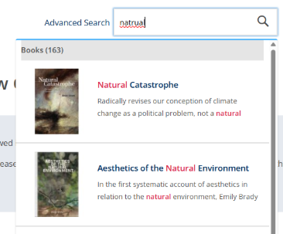

Microsoft Edge

For Edge, the browser spell check did not highlight the error with a red zigzag line. Corrected results were suggested:

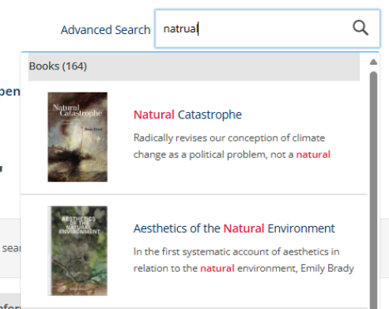

A spelling correction is provided above the search results:

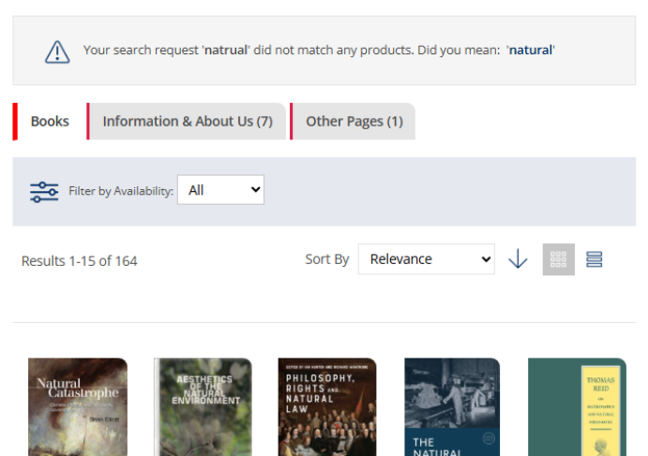

In Advanced Search, there was no spell check and no corrected results were suggested:

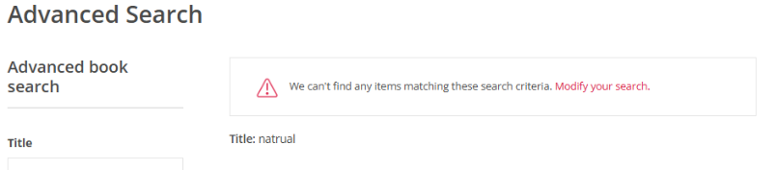

Firefox
Incorrect spelling is not highlighted in the search box in Firefox. However our built-in synonym checker returns the appropriate results. This was tested across multiple words with example of ‘ptriarchy/patriarchy’ shown below.
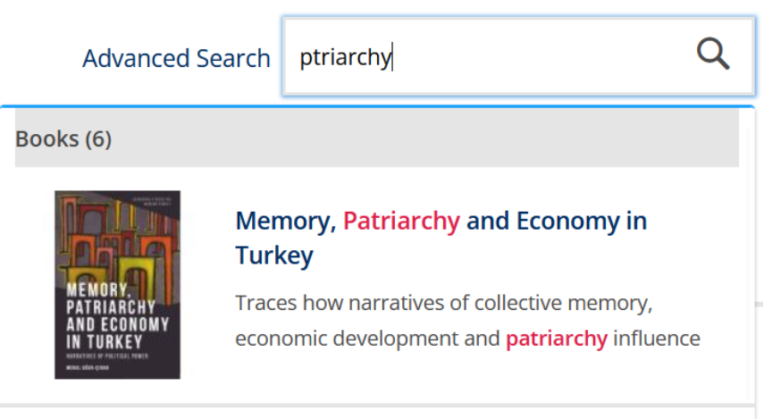

If you click through to the full search results, this message appears, highlighting books that contain the corrected work in any part of the metadata.
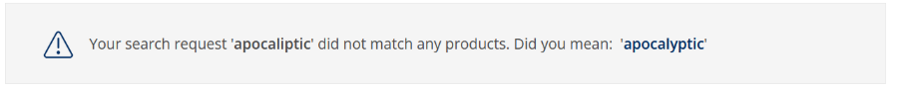

2. Describe any data validation that is automatically run by the system to ensure that users enter data in the correct formats. How does the system inform the user of errors?
- What sort of free text boxes in the system would require data validation?
- Are users alerted if they enter information in an incorrect format e.g. phone number as letters
- Are user alerted if they miss out mandatory fields?
- Are error messages consistent across the system?
- Are error messages of sufficient colour contrast?
- Do error messages appear on the main page (not as pop ups)
- Do error messages indicate the location of the error
- Do error messages give a clear description of the error and how to resolve it?
- Do the errors appear as pop ups?
- Does the system suggest alternatives to incorrect data entry where appropriate

There does not appear to be any validation in fields that would require it. For example, if letters are entered in the ISBN field in the Advanced Search, no results are returned. There is no data validation in the address fields in user accounts or newsletter sign ups, e.g. letters can be saved in the telephone number field and no errors appear.

On newsletter sign-up pop-ups, keyboard navigation does not reach the X button but the escape key can be used to dismiss it.

3. If a form requires the user to repeat information, for example, their address multiple times, is there an option for the system to automatically fill in this information if it has been provided previously?

There does not appear to be anywhere where users must repeat information. Addresses can be saved to the user account where they can be selected without re-entry.


4. Is a cognitive function test required to access this site? E.g. do you need to remember a password? (This is negated if there is a forgotten password link or an object recognition option that allows you access.)

There is a forgotten password link to access user accounts for purchases which is present before the user puts in their password incorrectly. There is no CAPTCHA on the site when purchasing or logging in.

5. Is the system compatible with browser functionality to allow the user to customise their views (i.e. font size, colours, and contrast ratios).

a. Desktop
- Test the customisation of the site on all browsers. (include screenshots)
  - Does everything change – record what content does not change
  - Is any content lost – record what content is lost

Before

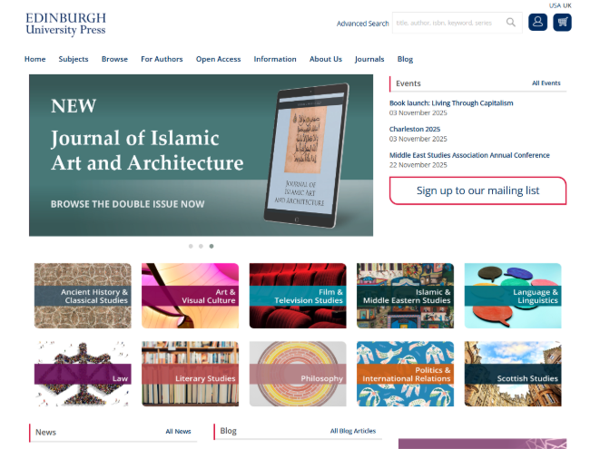

Microsoft Edge
It is possible to change the background colour using Edge accessibility settings with no loss of content. The text also changes colour, with the exception of the placeholder text within the search bar at the top. No colour contrast errors are detected by manual looking or automated testing in WAVE.

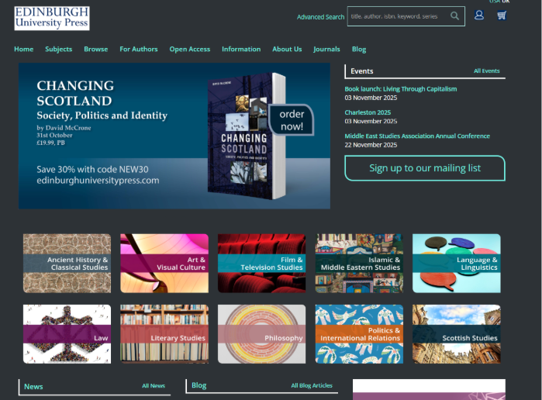

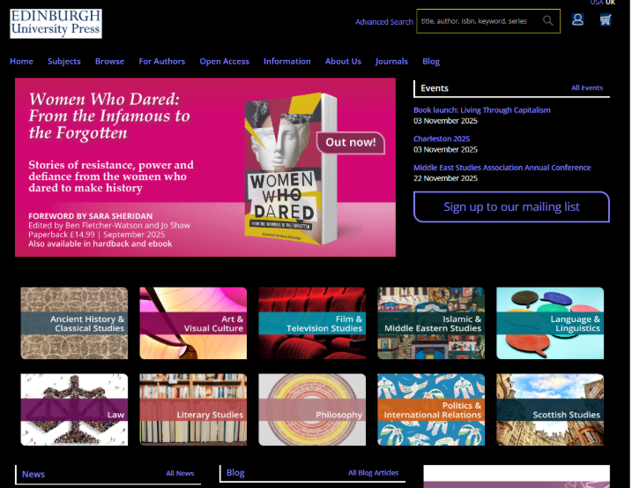

Chrome
It is possible to change the background colour using the ‘Color Changer’ browser extension. When colour change is activated the images and buttons remain static, while the top search bar changes colour but is still visible. The text colour of links changes colour and changes again once links are clicked. No text or link context is lost through the use of the colour changer.

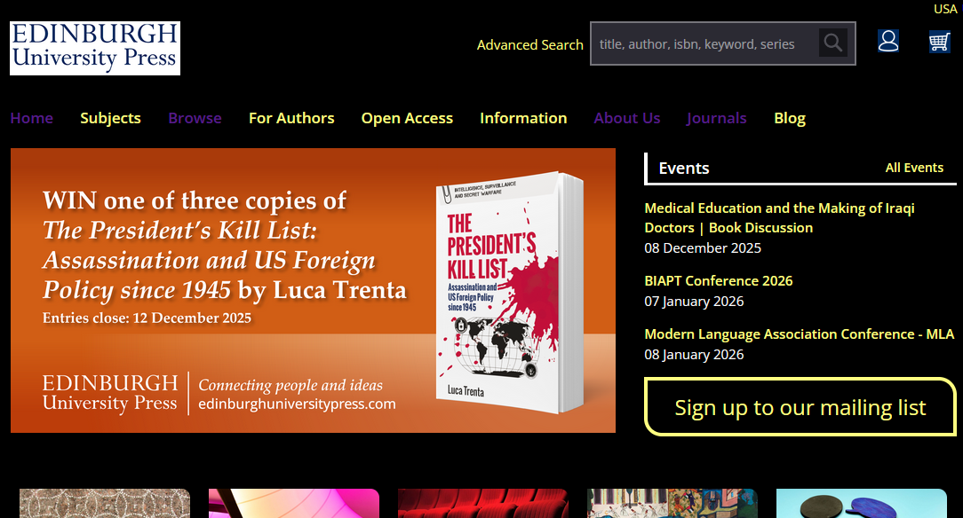

Firefox
Switching on dark mode does not affect change on the EUP website. Using the contrast customisation tools, it is possible to change to a dark background, select text colour and choose how hyperlinks are highlighted. It is possible to set a specific zoom level for the site with the site adjusting well up to 150% on a laptop screen. Display is adversely affected at 170%. It is not possible to amend the default font or font size.

- Are there any colour contrast issues identified – by automated testing and by manually looking? Record these and include screen shots

Colour contrast was checked using the WebAIM WAVE tool. Some of the price buttons have lower contrast by eye but which fall in the acceptable range.

Across all pages, an instance of very low colour contrast was flagged in the footer, where the text ‘About’, ‘I’m looking for...’ and ‘Contact’ has a contrast ratio of 3.73:1. This fails the WCAG 2.2 AA 1.4.3 Contrast Minimum criteria.

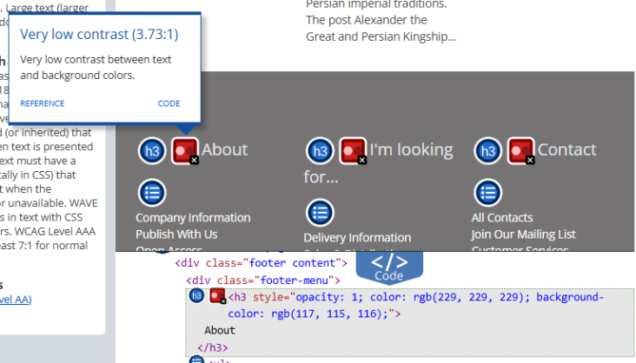

Colour contrast errors (very low contrast) were flagged on the product pages, failing to meet the WCAG 2.2 AA 1.4.3 Contrast Minimum criteria:

The text on the format option buttons has a contrast ratio of 3.45:1
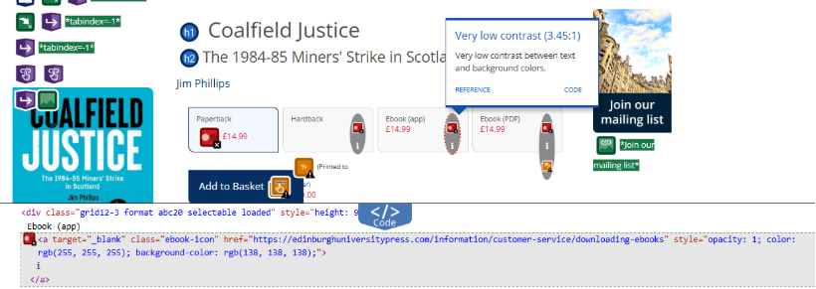

The text on the ‘Show less’ button has a contrast ratio of 3.45:1
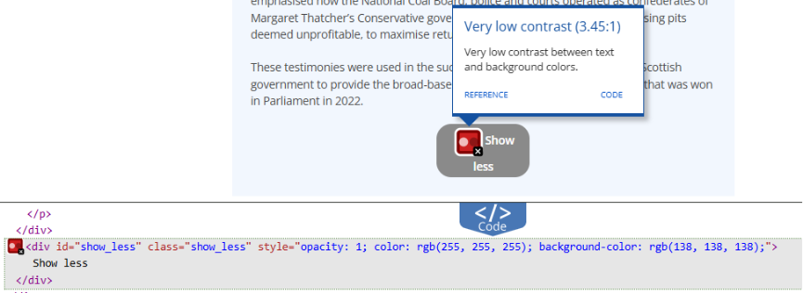

- Is there use of italics, continuous capitals or underlining?

There appear to be no instances of text underlining in the site.

There are some instances of italics being used on the site. These are for academic references i.e. journal and book titles.
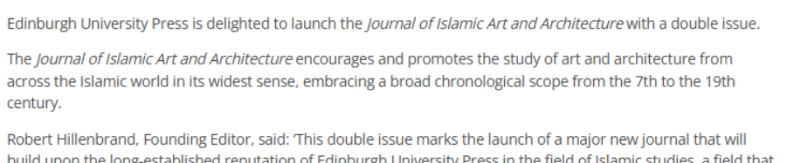
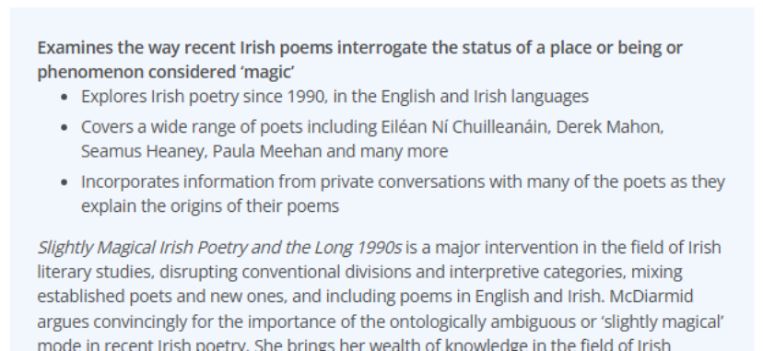

There does not appear to be any use of continuous capitals in the text on the site, except in the case of acronyms which have been written out in full earlier in the text:

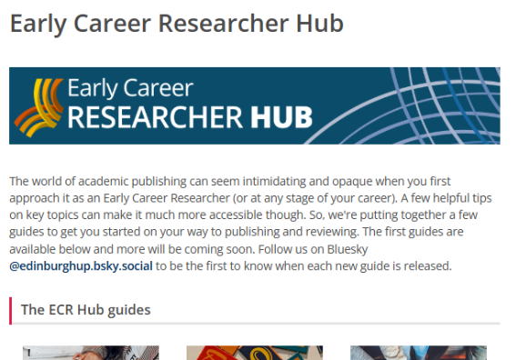

Several images contain text in continuous capitals, such as the banner in the screenshot above, the company logo and book adverts which are also image as text:

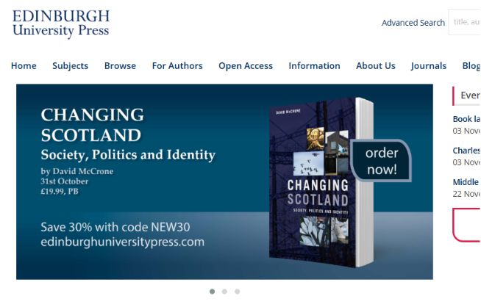

- Is the font size large enough (12pt or larger?)

There are instances of small text being used throughout the website, for example:

The below text uses the size 7.5pt:
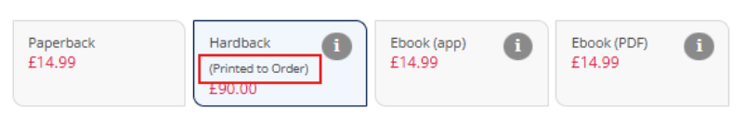

The below text uses the size 9pt:
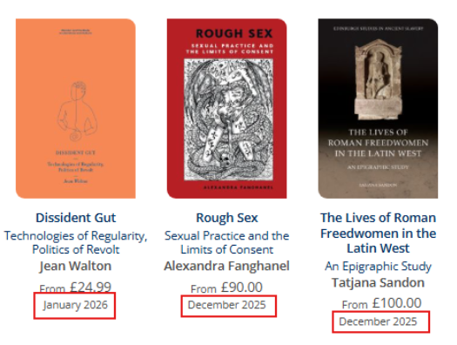

- Is the font serif or sans serif?

There appear to be no instances of serif text being used in the text on the website.

Serif text is used occasionally in images, including the company logo and some book banner adverts:

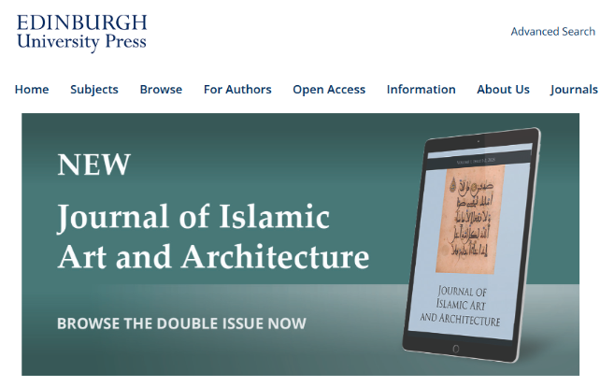

- Are all links formatted correctly with meaningful hypertext?

Links in the site appear to be formatted with meaningful hypertext. There do not appear to be any naked URLs. All links are meaningful and include descriptive text, such as “Find out more about Book Title”.

Links with information by colour error: most of the links in the website are highlighted by colour and bold formatting only. They should be underlined.

New tab indication error: there is no indication whether links will open in the same tab or in a new tab. E.g. in the screenshot below, ‘Explore the list of publisher open access agreements’ opens in a new tab, whereas ‘Return to the OA Hub homepage’ does not.

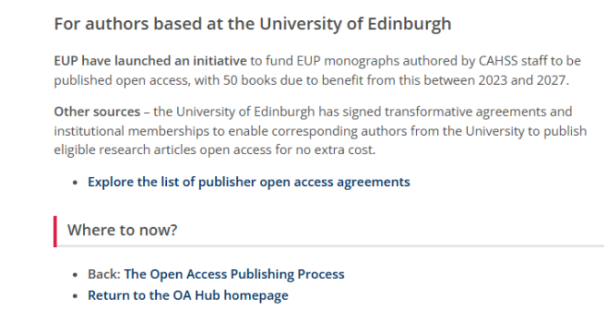

b. iOS (mobile device)
- Test bold text
- Test larger text
- Test increase contrast
- Test smart invert and classic invert

The website responds to enabling bold text in accessibility settings.
The website does not respond to enabling larger text in accessibility settings.
The website does not respond to enabling increase contrast in accessibility settings.
The website is responsive to colour inversion using smart invert and classic invert settings. Smart invert preserves original image colours giving a true representation of book covers and other images throughout the site.

c. Android
- Test display size and font size
- Test high contrast text
- Test dark theme
- Test colour inversion

Samsung internet browser (Android) does not have an inspect element feature so it is not possible to confirm the display size or font size. (It is possible to adjust this by % as noted later). Applying the high contrast setting has minimal effect on the text but colour inversion setting are effective. It is possible to view the site in dark theme.

6. Confirm whether the system scales correctly using different resolutions and if the system reflows when magnified.
a. Desktop

- Windows Magnifier
  - Use this application to test magnification up to 500%
  - If any distortion record at what magnification level this occurs

Windows Magnifier was able to magnify content up to 500% without distortion.

- Ctrl +
  - When using ctrl + to magnify the page what percentage up to 500% can be reached before distortion/overlapping/loss of content?

In Edge, Firefox and Chrome, it is possible to magnify the site using the Ctrl+ keys up to 500% with no distortion, overlapping or loss of content so long as the page does not go into mobile mode. When the browser window is made very narrow, the page re-adjusts to a more vertical-oriented view and the top menu is compressed to a three-line hamburger menu. This menu is not accessible via keyboard navigation. For best results, use a full screen window.

- Reflow
  - When you use ctrl + to magnify the page, does the site resize in a way that means the user doesn’t need to use horizontal scrolling to reach all content?
  - At which magnification level is this operational to? Check up to 500%.

In Edge, Firefox and Chrome, the site can be scaled to 500% without the user having to scroll horizontally, except for pages containing information laid out in tables. For example, the ‘Meet the books editorial team’ page:

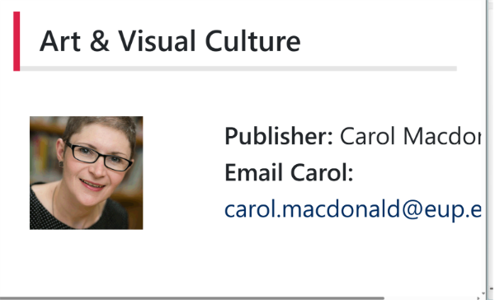

On the account sign-in page, the text is reflowable up to 500% and no content is lost, however horizontal scrolling is enabled to show white space on the right-hand side of the page.

b. iOS (mobile device)
- Using pinch and expand can you magnify content
- Using zoom functionality can you magnify content

Users can pinch and expand to enlarge content on the website in iOS, or use the accessibility settings zoom feature to magnify the screen up to 15x.

c. Android
- Using pinch and expand can you magnify content
- Using zoom functionality can you magnify content

Users can pinch and expand to magnify content on the website in android, or increase the text size up to 200%. Zoom functionality is satisfactory up to 200%, but layout becomes distorted at higher levels.

7. Confirm whether the system conveys any information in colour only?
- Is colour used to identify items e.g., priority items are shown in red
- Is colour used in graphs, diagrams, calendars as the sole method of conveying information?

There are many links which are formatted using colour and formatting only and are indicated by a change in colour when navigating over them using a cursor or screen reader. There do not appear to be any other areas where colour is the sole method of conveying information.

8. Is there any flashing, scrolling or moving content?
- e.g. a moving carousel, video or graphic?
- Can this content be stopped or paused by the user?
- Is the method by which the person can stop or pause the content accessible – reach by keyboard, colour contrast etc.

Scrolling: There is a scrolling banner on our home page which does not have a pause button. There is no flashing content and there is no other example of moving content.

9. Confirm whether all content is accessible through a keyboard interface and whether it requires specific timings for keystrokes (i.e. is it possible to navigate around and complete the task without ever using the mouse?).

The below keyboard accessibility findings are consistent across Edge, Firefox and Chrome.

Can all content be reached by keyboard alone?

Most of the content appears to be reachable using keyboard navigation alone, however there are some key functionalities that are inaccessible:

Product pages have two issues:
- It does not appear to be possible to select different book formats using keyboard navigation. E.g. below, the path the Tab key takes you on is: author name > ‘i’ button > ‘i’ button > Add to Basket.
- It is not possible to select the ‘Show more’ link to show the full book description – this is skipped over when navigating using keyboard only.

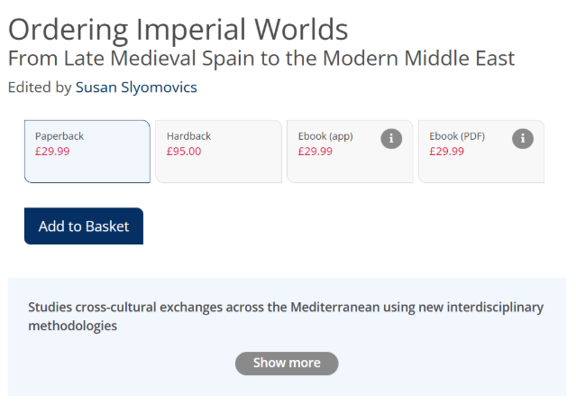

There does not appear to be a keyboard command that will open the nested elements of the side-menu. E.g. below, using a keyboard alone, I cannot expand the ‘Early Career Researcher Hub’ nested menu:

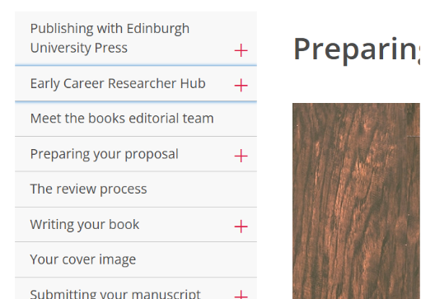

The nested options in the navigation menu at the top is inaccessible via keyboard navigation. Additionally, When the browser window is made very narrow, the page re-adjusts to a more vertical-oriented view and the top menu is compressed to a three-line hamburger menu. This menu is not accessible via keyboard navigation. For best results, use a full screen window.

- Do you get stuck in an area or on content and then are unable to progress through the site, e.g. a keyboard trap? Can you only escape this area using a mouse?

There do not appear to be any keyboard traps.

- When tabbing through the site or application using the keyboard, does the navigation follow a logical order through the content?

The keyboard navigation appears to follow a logical order through the content. However, the top level (logo, basket, account, UK/US site buttons) does not go top to bottom, left to right. On information pages, the nested menus on the left-hand side are only accessed once the content in the middle section is navigated through.

- Can you easily identify where you have navigated to on the page by the selection displays (an outline on the item that you are currently on)?
  - Selection displays must have sufficient contrast to the selected item and not be fully obscured by any other content on the page, for example a cookie banner or a drop down menu

Hyperlinked text is highlighted using a blue outline:

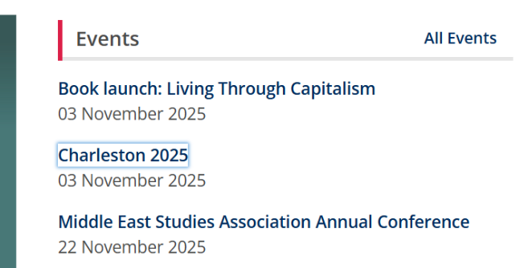

When the top menu is selected it is highlighted in blue and you can move along the menu options using the right/left arrow keys, however there is no indication of which specific menu item you are on. You therefore also cannot expand the dropdown menus using a keyboard alone. E.g. below, I have navigated along to ‘For Authors’, which is where I would be taken if I pressed Enter:

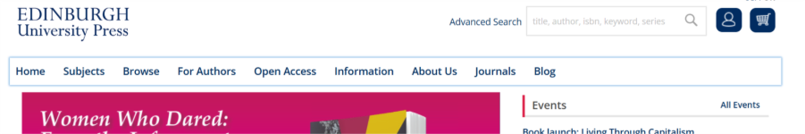

When the browser window is made very narrow, the page re-adjusts to a more vertical-oriented view and the top menu is compressed to a three-line hamburger menu. This menu is not accessible via keyboard navigation. For best results, use a full screen window.

There is little to no indication when hyperlinked images are selected. E.g. below, the ‘Art & Visual Culture’ tile is selected, and the only indicator is a small, faint blue dot to the top right of the tile:



- When tabbing by keyboard is there a skip to main content option?

Skip to main content option is present for the site.

10. Is TextHelp Read and Write compatible with the application?
TextHelp supports spelling and grammar checking, suggesting word completion, which proves helpful for people with reading difficulties (including dyslexia), typing difficulties, or a physical impairment. This software is available on all University public access PCs, and also via download from the Software Centre to a managed desktop.
- Can TextHelp Read and Write read aloud blocks of highlighted text?
- Are you able to hover over content and have it highlighted and read aloud?
- Is TextHelp Read and Write spellchecker compatible with the system
- Can TextHelp Read and Write apply a screen mask filter across the screen?

TextHelp Read and Write is compatible with all webpage types on this site on Chrome and Edge. TextHelp is not fully supported on Firefox but some features work with Firefox as described below.

Highlight and read
Highlighting text to read aloud worked on Chrome and Firefox, but Edge did not respond to the highlight and read function. However, you can get around this on Edge by using the Screenshot Reader function.

Hover highlight
Hover highlight worked only in Chrome, not in Edge or Firefox. For Edge and Firefox, you can get around this by using the Screenshot Reader function.

Spellchecker
Spellchecker worked successfully in Chrome, Edge and Firefox.

Screen masking
Screen masking worked successfully in Chrome, Edge and Firefox.

11. Is ZoomText compatible with the application? Can ZoomText be used without distortion of the pages content?
ZoomText allows users to magnify digital text and change contrast, for example, black text on white instead of white text on black. It is especially helpful for people with a visual impairment.
- Can you magnify all content up to 500% without distortion, overlapping or loss of content (no reflow with Zoomtext)
- Can you use the colour schemes to change all colour on the site?
ZoomText is compatible with the website, tested on Chrome, Edge and Firefox. It is possible to magnify all content to 500% without overlapping of content or reflow. However, some distortion does occur event at 100%. Screenshot below shows the same text at 100% in Chrome and 500% in Chrome (noting that the screenshot at 100% was of c. one ninth of the screen vs the screenshot at 500% which was virtually the whole screen). Images throughout the site are also pixelated (our guidelines point to optimum sizing for speed of loading, etc.)

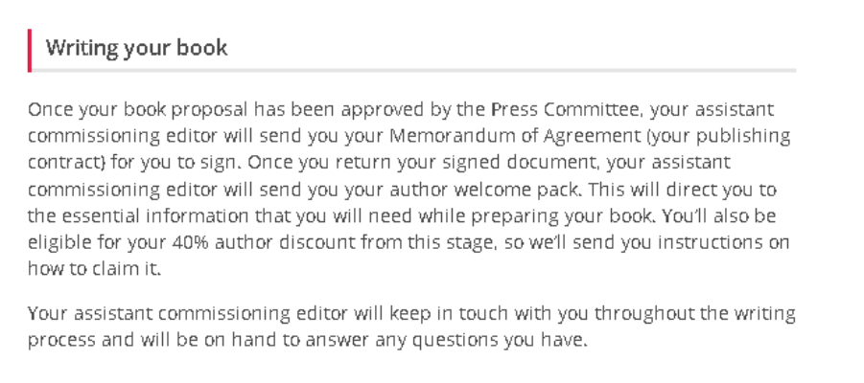
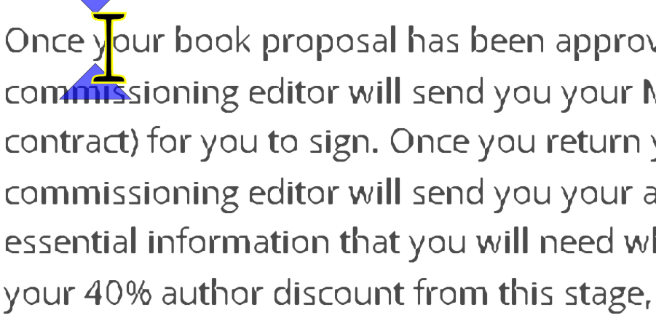
It is possible to use the colour schemes tool to change all pages on the site, including in the My Account area. Testing with Invert Colour shows hyperlink rollover with colour change, but using Yellow on Black only makes the bold text roman.

12. For all non-text content is there alt text/text descriptions added?
- Do logos, pictures and images have alt text?
- Is the alt text appropriate and sufficient?
- For infographics is there a full text alternative?

Logos, photos, pictures, book covers and banners all contain alt text. In some cases this is very simple and may not give sufficient information, such as book covers which just contain the book title. We do not currently host any infographics.

There are some examples of image-as-text on the homepage, where banner images serve as advertisements. These have descriptive alt-text and link to text content or product pages.

13. Is Job Access with Software (JAWS) Compatible with the application?
JAWS is a software package that converts text to speech, and therefore a useful tool for blind and visually impaired users.
- Can JAWS read all of the content on the site?

JAWS was tested on several page layouts (homepage, subject area page, information page, product page) and was able to read all content.

- Does it read the content in a logical order?

On page load, JAWS summarised page layouts in terms of frames, regions, headings and links.

JAWS then read the content in a logical order. However, the top level (logo, basket, account, UK/US site buttons) does not go top to bottom, left to right. On information pages, the nested menus on the left-hand side are only accessed once the content in the middle section is read through.

- Does it recognize links and free text boxes as such

JAWS recognised all text boxes as such and almost all links. The only exceptions regarding links are the same as outlined in the keyboard navigation section above:
- The ‘plus’ symbols which expand the nested side-menus were not recognised as links.
- The different format options on a product page were not recognised as links.
- The ‘Show more’ button on a product page was not recognised as a link.

- Does it repeat any content unexpectedly?

JAWS did not repeat any content unexpectedly.

- Is there a skip to main content option?

Yes, JAWS identified the Skip to Main Content option.

- Does JAWS read out the correct information on how to operate an item, for example a drop-down menu?

JAWS explains how to operate most items on the website e.g. checkboxes, expanded menus, text boxes, etc. However, it does not explain or recognise the drop-down menus, similar to the keyboard navigation functionality. For example, when you navigate to the top-level menu, it reads out how to navigate through the menu items using left/right arrow keys, but it does not recognise the drop-downs below each menu item. It does not appear to be possible to get these drop-downs to work at all using JAWS.

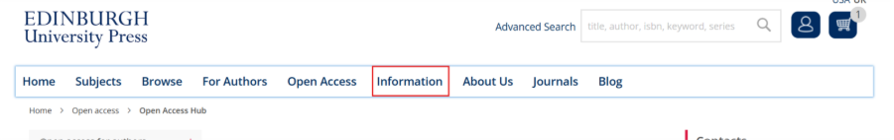

- Are all links formatted correctly with meaningful hypertext?

Yes, all links are formatted with meaningful hypertext which JAWS read aloud.

- Does insert F6 list all headings correctly

Insert+F6 lists almost all headings correctly. However, in the homepage below it doesn’t list ‘News’ as a heading and some heading levels are skipped. There also seems to be a redundant link name for ‘New: Journal of Islamic Art and Architecture’ which leads to unnecessary repetition. These are formatting errors for us to fix rather than JAWS functionality errors.

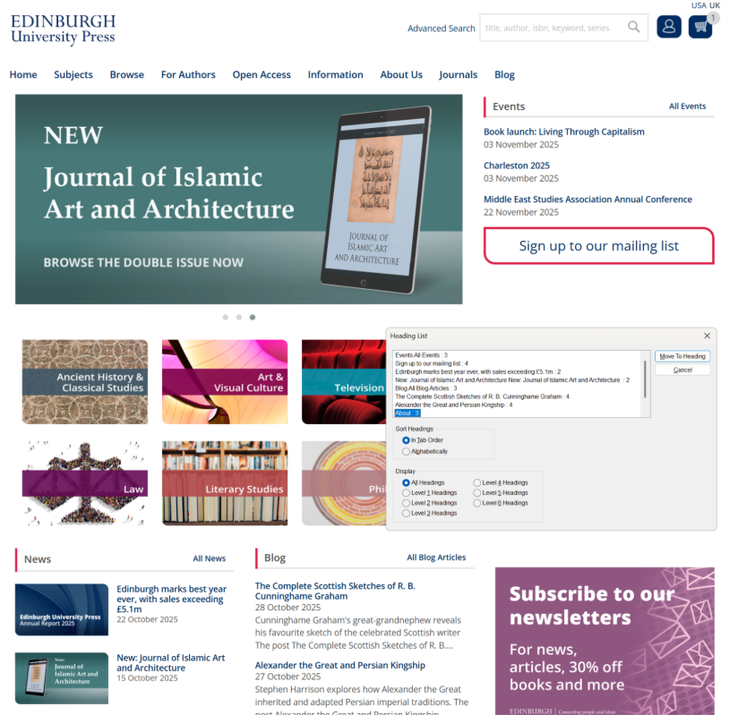

- Does Insert F7 list all links correctly

Insert+F7 does list all the links present in the page.

14. Is Dragon NaturallySpeaking compatible with the website?
- Are you able to navigate around the site using Dragon and reach all of the content?
- Can you open a dictation box without interfering with the content of the site?
- Can you access and activate links correctly using Dragon?
Dragon is a speech recognition software package that allows users to interact with a device through voice commands.

Dragon was mostly compatible with the site. It was possible to use tab to navigate through links and pressing enter worked to click on links. However, some issues found in Q9 around keyboard navigation also impacted the use of Dragon. Some content could not be accessed when tabbing, such as the main menu item drop downs. However, there was more functionality with Dragon as these items could be accessed using the show links command. Additionally, when tabbing the navigation did not always follow a logical order in the top menu as items were not accessed from left to right as expected.
Some selection displays were also poor in showing users where they had navigated to when using Dragon.

On all browsers, scrolling through pages and opening dictation boxes worked well.

15. Are tooltips clear and enabled by default?
- Are tooltips present and are they enabled by default for all icons?

Tooltips are not present for the Account and Basket icons, however once logged in and items are added to the basket, hovering opens a sub-menu for both icons with links with meaningful hypertext:
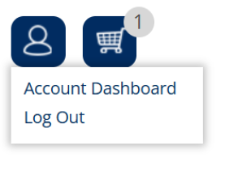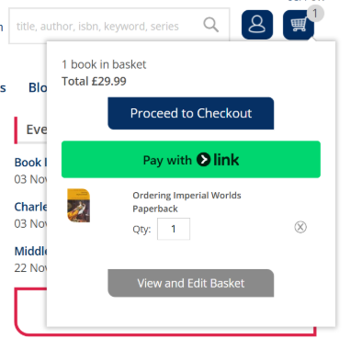

A tooltip is not present for the linked Glassboxx logo image in the footer:



Tooltips are present elsewhere throughout the site:
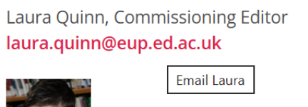

However, in some cases the tooltips are redundant as they duplicate the meaningful hypertext:
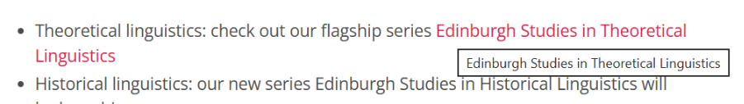
- Are they accessible when using keyboard, Dragon and JAWS as well as mouse over?

The tooltips are accessible when using keyboard navigation:
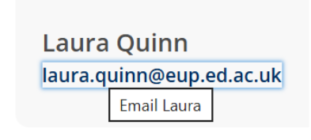
The basket tooltips are not accessible using keyboard navigation.

The tooltips are read aloud by JAWS.

The tooltips appear when navigating with Dragon.

- Does the content of the tooltip contain information required for the operation of the item?

The tooltips did not contain information required for the operation of the item.
- Does the tooltip significantly obscure other content on the page?

There is no functionality preventing the tooltips obscuring other content, so in some cases this does happen:

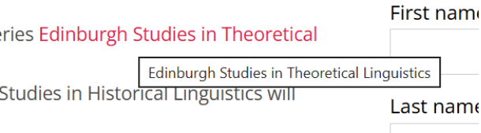

16. Accessibility of audio/visual content
- Is there a transcript?
- Are captions automatically enabled on audio/visual content (if not is the method for turning them on accessible?)
- Are captions human corrected?
- Are their live captions for live time video?
- Is there an audio description?

There is one book where there is additional audio content in the Resources section, Kathleen Jamie: Essays and Poems on Her Work (These are audio companions to poems published in the book, which serves as a transcript of the poems.

There does not appear to be any other audio/visual content on the site.

17. Is there an indication or warning of links which will open a new tab or a new browser tab/window?

There is no indication whether links will open in the same tab or in a new tab. E.g. in the screenshot below, ‘Explore the list of publisher open access agreements’ opens in a new tab, whereas ‘Return to the OA Hub homepage’ does not.

When users first visit the site, they will find pop ups on subject pages. These are escape-able using keyboard navigation (esc key).

18. Are there any time limits prescribed for the viewing/inputting of content by Administrators and/or Users?
- If there are time limits and is the user alerted to them and given the chance to extend them?

There does not appear to be any functionality on the site requiring time limits.

19. Is there any functionality on the site that requires the user to use a drag function, without any alternative way to interact with this element of the site?

There does not appear to be any functionality on the site requiring a drag function.

20. Is there a specialist help section provided online by the system to help the user with accessibility issues?
- Is there a help section with contact details in the same place on every page?

The ‘Contact us’ page is linked from the top-level menu and the footer. These are present on every page of the site at the same location. The hypertext in the footer is not the same as in the top-level menu – this could be changed to ‘Contact us’ for clarity.

Top menu: 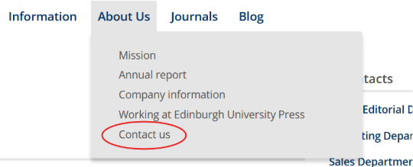

Footer: 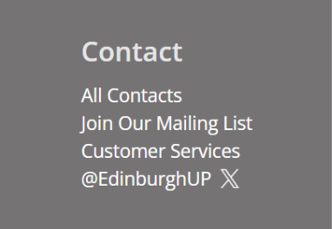

The footer is accessible by keyboard navigation and JAWS, however the top-level menu dropdown is not.

- Does the help section have contact details?

Yes, the help section contains contact details for general departments and individual staff members.

- Is there an Accessibility Statement on every page of the site or application, in compliance with The Public Sector Bodies (Websites and Mobile Applications) (No. 2) Accessibility Regulations 2018

There is information about accessibility on the site, but no formal Accessibility Statement in compliance with the above regulations exists at present.

- Is the accessibility statement based on manual and not just automated testing and dated in the last 12 months?

Not applicable – Accessibility Statement to be added.

21. Mobile device-specific

a. Text to speech
Is text to speech – Voiceover in iOS and Talkback on Android able to read the content of the site?

Android – The TalkBack function works well reading text through out the site. It can read simple menu items but struggles with sub menus.

IOS – The iOS Voiceover function worked well with the website to direct users to different parts of the site and read information on pages.
b. Orientation
Can the system be viewed in portrait and landscape mode on iOS and Android?

Android - The website can be viewed in both portrait and landscape modes.

IOS – The website can be viewed in both portrait and landscape modes.

Summary
In summary, the EUP Books/Corporate website has a good foundation for accessibility. However, several key issues remain to be addressed. Colour contrast issues exist in multiple areas, notably in the footer and on product pages where contrast ratios fall below WCAG 2.2 AA standards. There were examples of italics and continuous capitals found on the site. Not all non-text content has appropriate alternative text, and there are examples of images of text. Although the site supports browser customisation and magnification up to 500% without distortion, some small text (as low as 7.5pt) reduces legibility and should be increased and there are examples of serif fonts found on the site. There was also an issue identified around magnification, in that some content becomes inaccessible at higher magnification levels (175% and above). Additionally, reflow is enabled on most pages on the site up to 400% however on some pages like the log in page, horizontal scrolling is still required at higher magnification levels. Links are mostly formatted correctly, but some rely solely on colour change for identification, creating an information-by-colour error. Links that open new tabs or windows are not indicated, and this should be corrected. There are also pop ups that appear without warning the users. There is a moving carousel on the homepage that does not have any functionality for the user to pause this movement. Some heading levels are skipped or not used appropriately. Keyboard navigation is largely effective, but key elements—such as “Show more” buttons, product format selectors, and dropdown menus—are inaccessible using keyboard alone. Additionally, the keyboard focus does not go through the site in a logical order, meaning the focus indicator skips over some items and then goes back to them, instead of navigating from left to right, and top to bottom as expected. Visual focus indicators are faint, making navigation difficult for users relying on keyboard interaction. Screen reader testing (JAWS) revealed similar gaps: nested menus, expandable content, and some links were not recognised. Dragon compatibility could also be improved as issues that affected keyboard navigation also impacted Dragon. Tooltips are inconsistently applied, missing on some icons (e.g. Account and Basket), and occasionally obscure other content. TextHelp Read and Write compatibility is good on Chrome and Edge but limited on Firefox. While the site supports colour inversion on both iOS and Android, it does not respond to larger text or increased contrast settings on iOS. The website currently lacks a compliant Accessibility Statement as required under The Public Sector Bodies (Websites and Mobile Applications) (No. 2) Accessibility Regulations 2018. Implementing this should be a priority.

Areas to follow up
- Improve text readability
  - Increase all small text (below 12pt) to meet accessibility standards
  - Avoid small font use (7.5pt, 9pt) across informational and navigation areas
  - Address colour contrast issues in footer and on product pages, ensuring all text meets WCAG 2.2 AA 1.4.3 Contrast Minimum standards
  - Address use of serif fonts
- Ensure reflow is enabled up to 400% across all pages without any loss of content
- Ensure that at higher magnification levels (175% and above) there is no loss of content
- Implement data validation for form fields and display clear, accessible error messages
- Fix link formatting
  - Avoid colour-only indicators for hyperlinks; ensure underlining and strong contrast
  - Add clear warnings when links open in new tabs or windows or as pop ups
  - Ensure links re all meaningful hypertext
- Ensure all site elements (dropdowns, expandable menus, product format selection, “Show more” buttons) are accessible via keyboard
- Improve focus indicators with higher contrast outlines for selected items
- Ensure keyboard navigation follows a logical order through the site
- Improve JAWS recognition of nested menus, expandable elements, and skipped heading levels
- Improve Dragon compatibility with the site to ensure all content can be reached
- Ensure all heading levels follow a logical order and are announced correctly
- Add tooltips to all interactive elements (e.g., Account, Basket, Glassboxx) and ensure they are accessible by keyboard and assistive technology
- Ensure tooltips do not significantly obscure other content
- Ensure tooltips do not contain information necessary for the operation of the system
- Ensure pop ups do not appear without the user interacting with anything on the site
- Ensure all non-text content contains appropriate alternative text
- Ensure any examples of text as an image contain appropriate alternative text
- Ensure that any moving content on the site can be stopped or paused by the user
- Ensure responsiveness to larger text and increased contrast on iOS
- Create and publish a dated Accessibility Statement based on manual testing

For more information on this report or to ask any questions please contact Kirsten Knight via email: accessibility@eup.ed.ac.uk.

