Alt Text Guidelines

What is alt text? Why do we need it?
Alt text, or alternative text, is a short text description of the visual details of an image which can be read out by assistive technology, such as screen readers. It allows people who use this technology – for example, those with visual disabilities – to understand a book, journal or website’s visual content. It is also useful for some people who find too many images distracting or overwhelming and prefer to look at webpages or ebooks without them showing. Alt text is not visible in the printed book/journal or in the main body of the text; it is within the digital files of the ebook.

Guidelines for writing good alt text
Describe the essential aspects of the image accurately and concisely. Imagine that you are describing it to someone over the phone – you want them to be able to understand the key features and relevance of the images quickly.
Keep it brief, usually around 1-2 sentences and under 100 words.
There’s no need to start with ‘An image...’ or ‘a picture…’, as screen readers include this automatically. However, you can add a specific descriptor if helpful for understanding the image, e.g. ‘A line graph showing…’, ‘A screenshot of…’, ‘A painting of…’
Any pertinent text in the image should be transcribed and put within quotation marks.
Spell out any numbers or contractions.
Some symbols cannot be read by screen readers and should not be used: – × ÷ = *
The tone should be neutral and in keeping with the rest of the text. Avoid subjective or superfluous adjectives, e.g. pretty, ugly, funny etc. Any critique should be kept within the main body of the text.
Make sure to conclude the alt text with a full stop (period), which allows screen readers to pause before continuing on with the main text.
Things to avoid
- Do not include unnecessary details or information.
- Try not to use punctuation within the alt text unless necessary for clarity.
- Do not replicate information that already appears in the surrounding text or caption

Not all images need alt text
Only images that contain information need alt text. Those which are purely for decoration can be left blank or marked as ‘decorative image’. Examples of images which would fall into this category include thumbnails; stock images used for ‘flavour’ rather than providing understanding; embellishments.

Alt text example
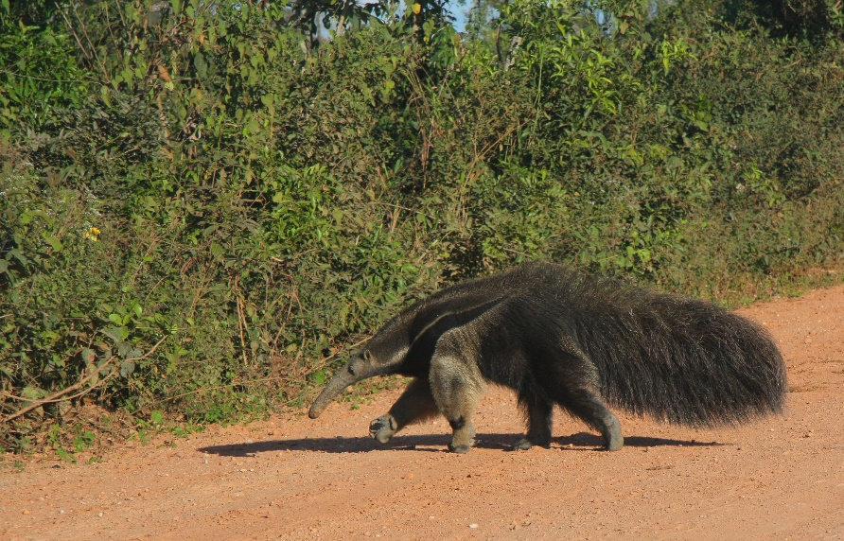
Caption: A giant anteater safely crosses the Transpantaneira (MT-060) in Mato Grosso, Brazil.
Bad alt text: Image of anteater
Better: A giant anteater walking
Best: A giant anteater walking towards a green hedge at the side of a red dirt road.

Long descriptions
Some images need more than 100 words to convey all of their detail and information. Long descriptions, or extended descriptions, can be as many words as are necessary – even multiple paragraphs – and are generally used for complex graphs, maps and diagrams, and images with a lot of nuance or detail which is important for understanding its purpose within the text.
Long descriptions can either be placed near the image (in a sidebar or within the main body of the text) or, more commonly, in a separate section or appendix. Wherever it is included, there should be a direction to it within the alt text, e.g. ‘An extended description of this image is on this page’ or ‘See the link below the image for an extended description’.

Guidelines for long descriptions
Make sure that the information is not already contained within the text near the image. If it is, you may not need a long description.
Long descriptions generally start with a short overview of the image, and move on to more specific and detailed information.
Long desciptions for images like graphs, charts, maps, flowcharts and diagrams should be written in a way as to describe all of the components of the image that add to the meaning,
E.g. for a graph, start with the title and the purpose, if it is not clear from the title.
State the type (pie, line, bar etc), and describe the information on the axes, spelling out any abbreviated words for units. Think about what information the graph is conveying to the reader and describe the data points, values, trends and conclusions that may be drawn by looking at it but are not stated in the text surrounding the image.
Not all graphs, charts etc. need a long description. If they are relatively simple, alt text should be sufficient.
Be as clear as possible and describe all of the details and elements of the image that are crucial for the reader to understand the meaning/purpose of the image.
Example:
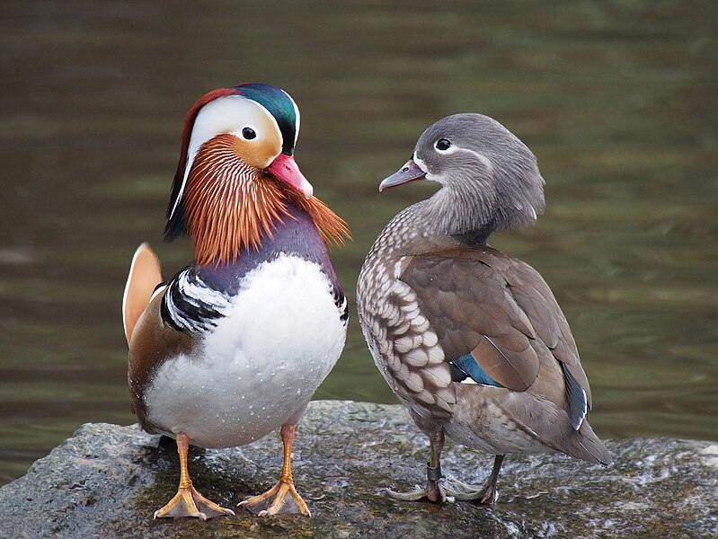
Caption: Pair of Mandarin Ducks (Aix galericulata), at Martin Mere, Lancashire, UK.
© Francis C. Franklin / CC-BY-SA-3.0
Alt text: A male and a female Mandarin Duck standing on a rock with water in the background.
Long description: Two Mandarin Ducks standing on a rock. The male duck is on the left and is in three quarters profile. It has a teal stripe down the middle of its forehead to its red bill. It has a white crescent around the eye and red-orange feathers down the front of its neck. The top of its chest is purple with a small black and white horizontally-striped patch on each side, about a third of the way down. Its belly is white and it has pale orange legs and webbed feet.
The female duck is facing away from the camera, with her head turned towards the male. It is predominantly grey-brown, with a small white line extending from its eye towards the back of its head, and a white line around the base of its grey bill. Its chest is light brown with white speckles which increase in size towards its belly. The feather on its folded wing are a darker brown and one, near the bottom of the wing, has a small teal flash. Its legs and webbed feet are brown.
The rock they are standing on has some guano on it to the right. There is brown water in the background, with a slight green tinge from the reflection of trees.

